|  |  |  |
| --- | --- | --- |
| LOGO | **T.C.**  **MANİSA CELAL BAYAR UNIVERSITY**  **FACULTY OF ENGINEERING**  **COMPUTER ENGINEER DEPARTMENT** | LOGO_muh |

**ARANIYOR.ML**

**GRADUATION PROJECT**

**PREPARED BY**

**160316054 – CAN ÇALIŞKAN**

**160315053 – AYŞE BETÜL ERTAN**

**160315058 – FİRUZE DAMLA ERYILMAZ**

Contents

[What is ARANIYOR.ml? 3](#_Toc503819758)

[USER REQUIREMENTS 3](#_Toc503819759)

[SYSTEM REQUIREMENTS 4](#_Toc503819760)

[Login Screen (1, 2, 3, 4, 7, 8) 4](#_Toc503819761)

[Sign up Screen (1, 2, 7, 8) 4](#_Toc503819762)

[Search Screen (4, 5, 7, 8, 9, 10, 14) 4](#_Toc503819763)

[“Hizmet Veren” s Profile Screen (7, 8, 11, 12, 13, 16, 17) 4](#_Toc503819764)

[Message Screen (5, 7, 8, 16) 5](#_Toc503819765)

[User Screen (7, 8, 15) 5](#_Toc503819766)

[“Hizmet veren ol” screen (7, 8) 5](#_Toc503819767)

[Admin panel (7, 8) 5](#_Toc503819768)

[System Stakeholders 5](#_Toc503819769)

[Functional Requirements 5](#_Toc503819770)

[Admin 5](#_Toc503819771)

[Hizmet veren 6](#_Toc503819772)

[Hizmet Alan 6](#_Toc503819773)

[Non-Functional Requirements 7](#_Toc503819774)

[Product requirements 7](#_Toc503819775)

[Organizational requirement 7](#_Toc503819776)

[External requirements 7](#_Toc503819777)

[Usability Requirements 7](#_Toc503819778)

[Scenarios 8](#_Toc503819779)

[Sign In and Entering Scenario 8](#_Toc503819780)

[Search to service provider in system 8](#_Toc503819781)

[Send message to service provider from system 8](#_Toc503819782)

[Block the Disturbing User 8](#_Toc503819783)

[Voting of the Person Serving 9](#_Toc503819784)

[Comment on the Service Provider 9](#_Toc503819785)

[Being a service provider on the System 9](#_Toc503819786)

[Use Case Diagram 12](#_Toc503819787)

[Database Diagram 13](#_Toc503819788)

[References 14](#_Toc503819789)

# What is ARANIYOR.ml?

* ARANIYOR.ml is a virtual superhero who will grow up to help the needy as soon as possible.
* ARANIYOR.ml is a web site that provides the fastest way for its users to get service. ARANIYOR.ml is a solution for those who can not find the service with ease, the service provider will come to work. Easy user interface will handle the user's work.
* People who are having trouble finding work will be able to get a job as a member on the site (so much more).
* Users will be able to communicate with each other in a way that is not a mediator between them, and will be able to getting serve and giving serve easily.
* People who want to get services may have accurate and detailed information about the person who provides services. According to the ratings and comments made about the person who can receive service can choose with ease.
* They can block people who are members of this website for different and unwanted purposes and use the site more reliably.
* Users can easily reach their destination by passing the service they are looking for through certain filters.
* Users can easily reach their destination by passing the service they are looking for through certain filters.
* The service network in the web site is very large and will be expanding day by day.
* Thanks to the ability of the website to work in every environment, users can easily benefit from the web site on any platform.
* The service provider can see the number of views of his profile, see what level he is at, and have an idea of how much he needs to improve himself.

# USER REQUIREMENTS

1. The user should be able to log in easily and easily.
2. Sign in with Facebook and login with Gmail and login.
3. The ease of forgotten password must be presented to the user.
4. The option to filter the user must be presented.
5. The user needs to access the menus easily.
6. Users should be able to communicate with one another (need owner and service person).
7. The interface is simple and sleek in style.
8. The functional operations on the site must take place quickly. (such as recording, logging, filtering)
9. Must search by user location.
10. The user should be able to filter by price information.
11. The customer should be able to comment on the service he received.
12. The customer should be able to see their comments on the service they are looking for.
13. The customer should be able to score the service.
14. Must be able to filter services based on customer service scores.
15. It should be able to see the number of pages served by the service.
16. Users can block people they do not want.
17. The service provider introduces himself / herself.

# SYSTEM REQUIREMENTS

## Login Screen (1, 2, 3, 4, 7, 8)

* + It should contain summary information about the site.
  + The user should be able to login to the system.
  + If it is not a member, it should be directed to member's page.
  + Quickly sign in and sign up with Facebook and gmail.
  + The categories in the menu should be visible.
  + At the bottom of the page should be information about our site with information and contact sections and information on how to reach the site.

## Sign up Screen (1, 2, 7, 8)

* + Name, surname, Mobile Phone, E-mail, city, district and neighborhood, address, password. These fields are mandatory.
  + At least 8 carats should be checked for safety.
  + “Hizmet veren ol” button
  + It must be a user contract and must not be signed up without approval.

## Search Screen (4, 5, 7, 8, 9, 10, 14)

* + The job searched will be found in the menu categories.
  + After selecting the job to be searched, the Filtering section and all service providers will be listed. Filtering options; According to the rate, according to the price, according to the city.
  + Short information about the service providers will be displayed.
  + For displaying profiles, it will be buttons to view and communicate.
  + The score of the employer and the number of comments will appear.

## “Hizmet Veren” s Profile Screen (7, 8, 11, 12, 13, 16, 17)

* + Job information will be displayed in detail.
  + User comments will be shown.
  + Besides the comments, the service area will be rated.
  + It will be the profile picture of the service provider.
  + The communication will be a late button. And this button will be connected to the message screen.

## Message Screen (5, 7, 8, 16)

* + The user's chat history will be displayed.
  + Filter by name.
  + It will be ordered according to history.
  + It will leave in the form of a chat.

## User Screen (7, 8, 15)

* + Profile information should be shown and editing option presented.
  + Change Password.
  + It should “Hizmet veren ol” button.
  + It should be my messages section.
  + The profile should have the number counting statistics.

## “Hizmet veren ol” screen (7, 8)

* + Choose which services to provide from the categories.
  + Must fill in the fields of the properties of the selected service.
  + If it does not find the service to be provided, it should be a panel that will communicate with site administrators.
  + The service contract must be and user must be approved.

## Admin panel (7, 8)

* + All users should be able to see it dynamically.
  + All sites must be viewable.
  + Add, remove and edit categories.
  + Users must be able to block.
  + Communication users with users should be possible.

# System Stakeholders

* Admin
* Hizmet veren
* Hizmet alan

# Functional Requirements

## Admin

* + Admin can log in to the system.
  + Admin can view users in the system.
  + Admin can edit user information in the system.
  + User can be deleted from admin system.
  + Admin can add or remove new categories, or edit existing categories.
  + Admin users can block.
  + Admin can display blocked users.
  + Admin can view user conversations.
  + Admin can remove and edit comments about the user.

## Hizmet veren

* + The "Hizmet veren" system may register.
  + The "Hizmet veren" user can enter the system with the information.
  + It can edit and update account information for "Hizmet veren" accounts.
  + The "Hizmet veren" may send a message to another "Hizmet veren" user.
  + It can display "Hizmet veren" past chats.
  + It can search on the "Hizmet veren"system.
  + The "Hizmet veren" can comment on the services it receives.
  + The "Hizmet veren" may arrange comments made by other service providers.
  + The "Hizmet veren"profile can show how many people have entered.
  + "Hizmet veren" users may block.
  + The "Hizmet veren" may communicate with the person receiving the service.
  + The "Hizmet veren" can name the person who receives the service.
  + "Hizmet veren" can filter on the search screen.
  + The "Hizmet veren" users can sort by the number.
  + It may close the "Hizmet veren" account.
  + The "Hizmet veren" message history can be cleared.

## Hizmet Alan

* + “Hizmet alan” can register to the system.
  + “Hizmet alan” can login to the system with user information.
  + “Hizmet alan” can edit and update account information.
  + “Hizmet alan” can send a message to the serving user.
  + “Hizmet alan” can view past conversations.
  + “Hizmet alan” can search on the system.
  + “Hizmet alan” can comment on people who have been served.
  + “Hizmet alan” can edit comments itselfs made.
  + “Hizmet alan” can filter on the search screen.
  + “Hizmet alan” users can sort by rate.
  + “Hizmet alan” may vote for the person he serves.
  + “Hizmet alan” can block users.
  + “Hizmet alan” can turn off his account.
  + “Hizmet alan” can delete the message history.

# Non-Functional Requirements

## Product requirements

* + - Notifications should be communicated quickly to the user.
    - The software should support 100 million users.
    - The software should work on all Windows, Linux and MacOS versions.
    - The software must be mobile-compatible.
    - The software will provide 90% uptime.
    - The system must be secure. User information must be protected.
    - It should offer high performance to the user (such as filtering within 1 second)

## Organizational requirement

* + - The user must confirm their account information via email.
    - The user should provide an easy interface.
    - The user should provide good service quality.
    - The system should proceed in line with the stated mission and vision.
    - Notifications should be communicated quickly to the user.
    - Hints should be given to the user about the use of the system.

## External requirements

* + - The user must submit a contract and privacy policy.
    - Security of user information should be provided.

# Usability Requirements

The user interface of the system will be very simple. By using the computer through the Aranıyor.ml, admin , “Hizmet alan” and “Hizmet veren” will be able to use easily. Their learning and use is very easy. It is enough for users to click on what they want. Our interface is simple, understandable and easy. Effectiveness of use: It is easy to reach the targets quickly and easily with few mistakes. Users can access the system via facebook or gmail accounts. The user can change the position on any page. Tips should be given to the user about the use of the system. Customers and service providers should be able to communicate directly with each other. Admin users should be able to see and navigate easily.

Intuitiveness: the interface is easy to learn and navigate; buttons, headers and help / error messages are easy to understand.

Low workload perception: The interface seems very frustrating and annoying, easy to use.

# Scenarios

## Sign In and Entering Scenario

Ahmet moved to a new quarters. There is no recognition in the district he is in, and the new home is in need of care. He should paint the house and repair the taps. But since Ahmet does not know anybody around there, he does not have any idea where he will reach those who will do those renovations. What I am going to do is to find that your friend has already enjoyed using it and recommended it to him. The website comes to mind. You reach your website by searching through Google. Ahmet needs to be a member in order to use the application. Ahmet is also active facebook user. The site has been subscribed to the site by using the 'Register with Facebook' option.

## Search to service provider in system

Selin will go on holiday with his family. However, during the preparation, the mind has been put in serious detail. Where will the Selin leave the dog, Nuri? The hotel does not accept pets for the holidays. Selin has to entrust somebody to nuriyi, and any relatives do not accept nuriyi. Selin thinks that he can solve this problem through his website. Logging in .ml will select the dog care section under pet care from the categories section. It is searched for by the convenience that the ML offers to him, and by using the filtering feature according to the city and the sidekick, Tutkuya, a professional dog carer, is reached.

## Send message to service provider from system

Selin will go on holiday with his family. However, during the preparation, the mind has been put in serious detail. Where will the Selin leave the dog, Nuri? The hotel did not accept pets for the holidays. Selin had to entrust somebody to the nuriy and did not accept any relatives. Selin thinks that he can solve this problem through his website. Logging in .ml will select the dog care section under pet care from the categories section. It is searched for by the convenience that the ML offers to him, and by using the filtering feature according to the city and the sidekick, Tutkuya, a professional dog carer, is reached. Selin Tutkun examines the profile and then decides that he is the person he is looking for. Click on the send message button to communicate with your passion. Then they will talk about the subject.

## Block the Disturbing User

Laçin lives alone in Izmir. When she wakes up in the morning, she gets a big surprise when she goes to the bathroom to break her face. After throwing her teeth in the night, she forgot her taps and this caused the house to flood. As a result of long efforts, Lacin cleared the bathtub, but the water caused the furniture to bloom. By using the web site, Selim came to the master and changed the furniture. Master Selim has liked the Laçin and is looking for communication again on aranıyor.ml . This situation, which is very uncomfortable in this situation, is used to block the user who has been offered to her by the Lacin site, which prevents the master Selim and annoying situation.

## Voting of the Person Serving

Selin will go on holiday with his family. However, during the preparation, the mind has been put in serious detail. Where will the Selin leave the dog, Nuri? The hotel did not accept pets for the holidays. Selin had to entrust somebody to the nuri and did not accept any relatives. Selin thinks that she can solve this problem through his website. Logging in aranıyor.ml will select the dog care section under pet care from the categories section. It is searched for by the convenience that the aranıyor.ml offers to her, and by using the filtering feature according to the city and the sidekick, to Tutku, a professional dog carer, is reached. Selin examines the Tutlu’s profile and then decides that she is the person she is looking for. Click on the send message button to communicate with Tutku. Then they will talk about the subject. In the morning when they will go on a trip, Tutku will be delivered. At the end of the day, Tutku takes care of Nuri for 1 week and delivers Nuri. Selin is very surprised. Because she has received Nuri very healthy delivery. Selin, who is quite satisfied with Tutku, is being searched for helping herself and helping other people.

## Comment on the Service Provider

Selin will go on holiday with his family. However, during the preparation, the mind has been put in serious detail. Where will the Selin leave the dog, Nuri? The hotel did not accept pets for the holidays. Selin thinks that she can solve this problem through website which is aranıyor.ml . Logging in aranıyor.ml will select the dog care section under pet care from the categories section. It is searched for by the convenience that the aranıyor.ml offers to her, and by using the filtering feature according to the city and the sidekick,to Tutku, a professional dog carer, is reached. Selin examines the Tutku’s profile and then decides that she is the person she is looking for. Click on the send message button to communicate withTutku. Then they will talk about the subject. In the morning when they will go on a trip, Tutku will be delivered. At the end of the day, Tutku takes care of Nuri for 1 week and deliversto Nuri. Selin, who is quite satisfied withTutlu, is wanted to help Tutku and also to help other people so she suscribed and rate to Tutku.

## Being a service provider on the System

Burak is a senior at Computer Engineering. He has greatly improved himself in web design. He wants to further develop himself with new projects and at the same time to support his family in financial terms. Burak, who is an active user of arayanıyor.ml, thinks that he may also serve on the site. After logging in to the site and filling the required fields by clicking on the service provider button, the system is now among the service providers.

|  |  |
| --- | --- |
| *Scanario Name* | **Becoming a Member Scenario** |
| *Participating actor instances* | HizmetAlan:Araniyor.ml |
| *Flow of events* | 1. Ahmet clicked in signing up button. 2. The sign-up screen opens. Quickly sign up with facebook on the screen, and become a fast member with Google+. 3. Ahmet chooses the fast sign up option with Facebook. 4. The system connects to facebook and opens facebook page. 5. Ahmet opens his own facebook page. 6. After both sides have approved membership of Ahmet on aranıyor.ml . |

|  |  |
| --- | --- |
| *Scanario Name* | **Login Scenario** |
| *Participating actor instances* | HizmetAlan:Araniyor.ml |
| *Flow of events* | 1. Ahmet clicks on Login button. 2. The entering options screen opens. 3. Ahmet clicks on login with facebook. 4. Looking for aranıyor.ml to redirect to home. |

|  |  |
| --- | --- |
| *Scanario Name* | **Search in service provider system** |
| *Participating actor instances* | HizmetAlan:Araniyor.ml, hizmet |
| *Flow of events* | 1. Selin clicks on the categories option. 2. Selin selects the category of pet care in the categories. 3. Selin clicks on the pet care category. 4. Selin filters out Izmir from the city section. 5. Aranıyor.ml performing the filtering process and listing the results. |

|  |  |
| --- | --- |
| *Scanario Name* | **Send message to service provider on system** |
| *Participating actor instances* | HizmetAlan:Araniyor.ml, hizmet |
| *Flow of events* | 1. Selin clicks on the send message button. 2. The Messaging screen opens 3. Selin enters text in the text section. 4. Selin clicks on the send button. 5. Aranıyor.ml transfer the message to user. |

|  |  |
| --- | --- |
| *Scanario Name* | **Block the disturbing user** |
| *Participating actor instances* | HizmetAlan:Araniyor.ml, hizmet |
| *Flow of events* | 1. Laçin clicks the block the user button. 2. Aranıyor.ml prevents the user from associating with disturbing user. |

|  |  |
| --- | --- |
| *Scanario Name* | **Comment on the service** |
| *Participating actor instances* | HizmetAlan:Araniyor.ml, hizmet |
| *Flow of events* | 1. Selin clicks the view user profile button. 2. Selin enters the comment in the text section. 3. Selin clicks on the comment button. 4. Aranıyor.ml adds comment to user profile. |

|  |  |
| --- | --- |
| *Scanario Name* | **Scoring about the service provider** |
| *Participating actor instances* | HizmetAlan:Araniyor.ml, hizmet |
| *Flow of events* | 1. Selin clicks the View user profile button. 2. Selin selects the points to be awarded from the scoring section. 3. Selin clicks on the give rating button. 4. Aranıyor.ml adds the score to service provider profile. |

|  |  |
| --- | --- |
| *Scanario Name* | **Being a service provider** |
| *Participating actor instances* | HizmetAlan:Araniyor.ml, hizmet |
| *Flow of events* | 1. Burak clicks on the service button. 2. Aranıyor.ml directs you to the screen of becoming a service provider. 3. Burak fill in the required fields and click on the service button. 4. Aranıyor.ml checks the information. 5. If the information is correct, aranıyor.ml gives the authority to serve the user. |

# Use Case Diagram

**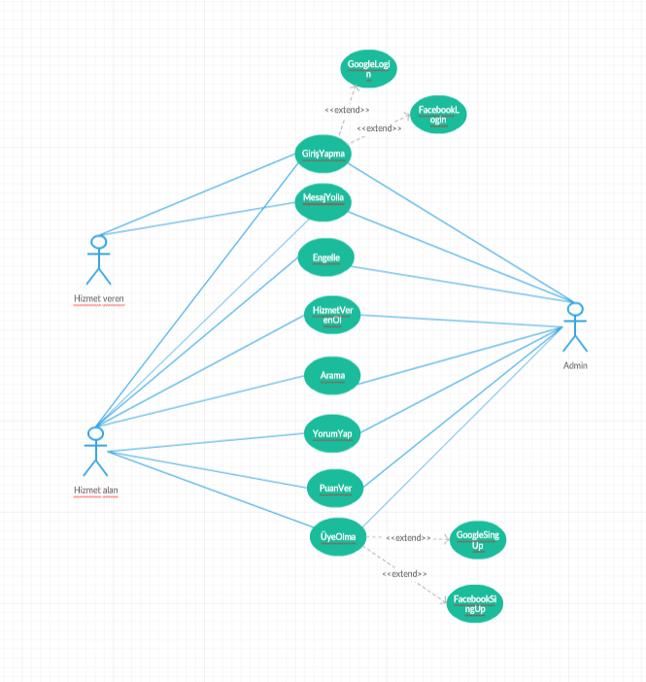**

# Database Diagram

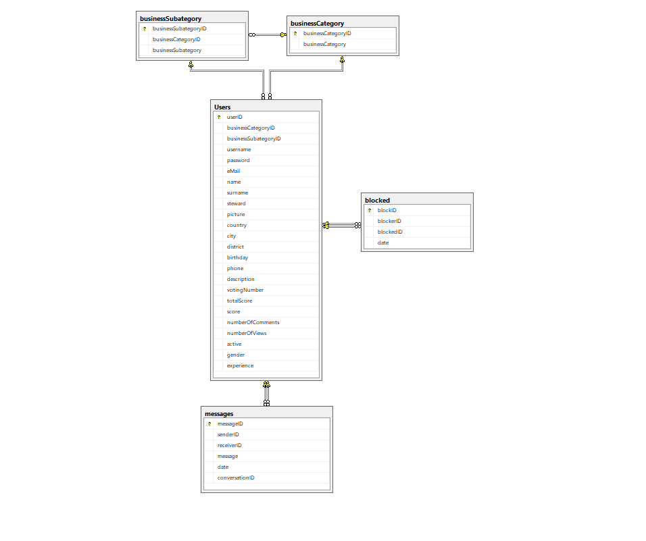

# References

**https://creately.com**

**https://www.uml-diagrams.org/index-examples.html**

**https://www.uml-diagrams.org/activity-diagrams-examples.html**

**https://www.smartdraw.com/state-diagram/examples/**

**http://reqtest.com/requirements-blog/functional-vs-non-functional-requirements/**

**http://www.ofnisystems.com/services/validation/user-requirement-specifications/**

**https://coderanch.com/t/99556/actor-stakeholder**

**Software Engineering Lecture Notes**

**https://www.lucidchart.com/pages/UML-use-case-scenario-examples**

**https://www.smartdraw.com/use-case-diagram/**